Tutorial 15

Some things to check before we start:
- You should see your DB file inside the solution explorer:
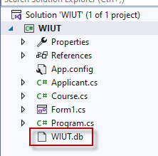
If it’s not there, do the following:
- Make sure that the file is actually there by opening the folder in Windows Explorer. If the file is elsewhere – copy it inside WIUT folder, if the file is nowhere to be found – create a new DB.
- Click on Show All Files in the toolbar of Solution Explorer, now you will be able to see all the files present in the folder. The files which are not added to project will be shown with dashed icons:
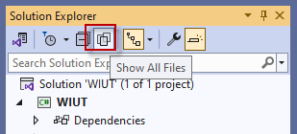
- Right-click WIUT.db and select “Include In Project” menu item:
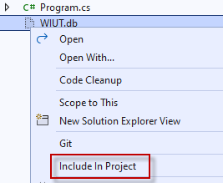
- Click again on Show All Files toolbar button to hide not-needed files and folders
- Make sure that DB file is copied to the project output directory – click on WIUT.db file in Solution Explorer and check Copy to Output Directory property, it should be set to “Copy always”:
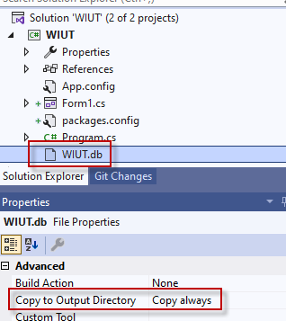
- Some tips regarding the database shown inside Sql Server Compact/SQLite Toolbox:
- If you see no database file inside the toolbox, you can use the option of Add Connections from Solution – it will register the .db file you see in Solution Explorer to the toolbox records:
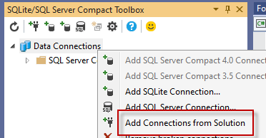

- Sql Server Compact/SQLite Toolbox does not carry the information between machines – you will need to add connections manually whenever you run the project from another PC.
- Beware that there will be two copies of the databases in run-time – the file from WIUT folder will be the master copy which will be copied to your \bin\Debug folder on every run. So if you want to see that your INSERT statement really worked, don’t check it against the master-copy DB, you should create another connection (right-click Data Connections => Add SQLite Connection => Browse inside \bin\debug folder)

Programming Exercise I – Preparing SQL statements
- Go to Tools->Sql Server Compact/SQLite Toolbox
- Right click the WIUT database in Data Connections and choose New query
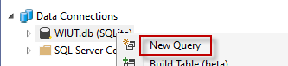
- Try to compose and execute SQL queries for CRUD operations for Course table:
INSERT INTO Course (Name) VALUES ('BA')
UPDATE Course SET Name='CL' WHERE Id=1
DELETE FROM Course WHERE Id=1
SELECT ID,Name FROM Course WHERE ID=1
SELECT ID,Name FROM Course
- HINT: you can generate any of the statements from the toolbox by right-clicking a table and selecting corresponding command:
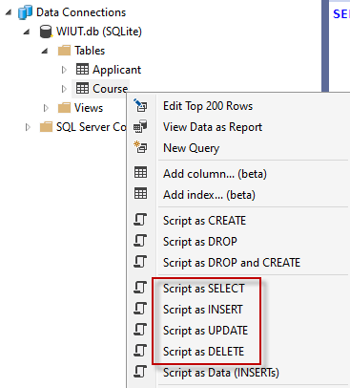

Programming Exercise II – Managers
Create a manager class for each of the DB tables.
- Right click solution in Solution Explorer and choose Add->New project
- Add new project of type “Class Library”. Call it WIUT.DAL.
- Delete default Class1.cs from the project
- Move Applicant and Course files from WIUT project to WIUT.DAL
- Update Applicant and Course
  - Make them “public”
public class Course
  - Change namespace to be WIUT.DAL
namespace WIUT.DAL
- Link the projects together – WIUT is going to use classes from WIUT.DAL so you should add reference accordingly. Right-click Dependencies node under WIUT project and select “Add Project Reference…”:
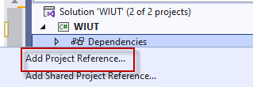
In the next dialog, select Projects tab and tick WIUT.DAL project:
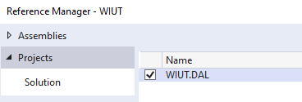
After that, click on OK button to complete the process.
- If you had some test code inside Form1’s Load event handler, it would stop working and will cause compilation errors. This is because we moved Applicant and Course classes to WIUT.DAL namespace. Add a line on the top of Form1.cs to reference WIUT.DAL namespace

using WIUT.DAL;

and the project will compile fine again:
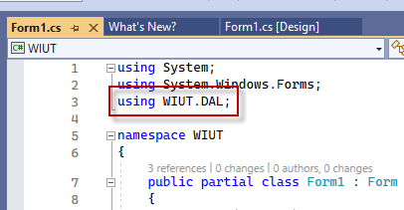
- Update WIUT.DAL to allow using Windows Forms:
  - Click on WIUT.DAL project in Solution Explorer or right-click it and select “Edit Project File”
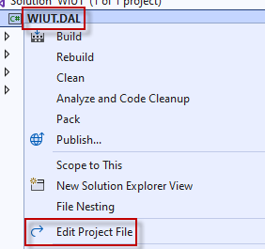
- Change the first line to be
<Project Sdk="Microsoft.NET.Sdk.WindowsDesktop">
- Add the following line inside <PropertyGroup> tag if it’s not there
<UseWindowsForms>true</UseWindowsForms>
End result should look like the picture on the right:
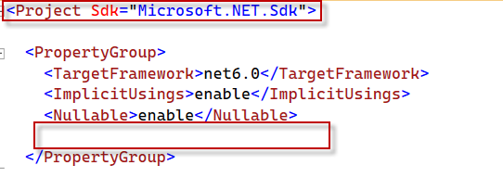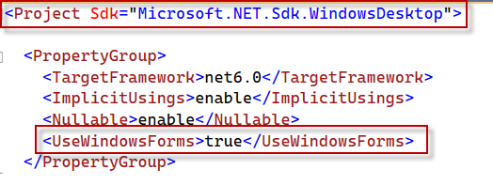
- Right-click your DAL project and select Properties
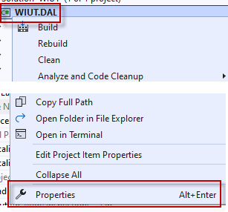
- Select Windows as your target OS:
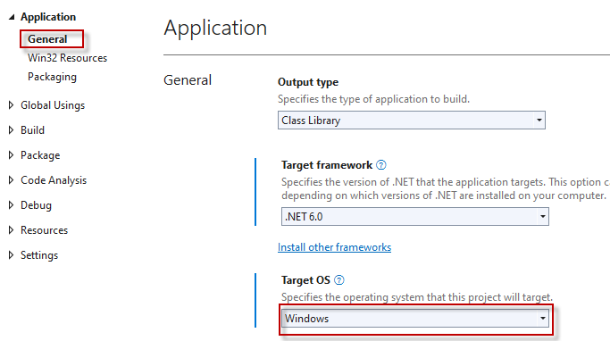

- We need to use NuGet package manager for getting required DLLs for SQLite connectivity. You may want to read more about NuGet here.
- Right-click Dependencies node under WIUT.DAL project and select Manage NuGet packages:
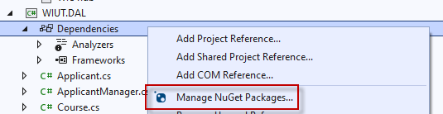

Make sure that you are on Browse tab, search for “system.data.sqlite”, select “System.Data.SQLite” package and click on Install button:
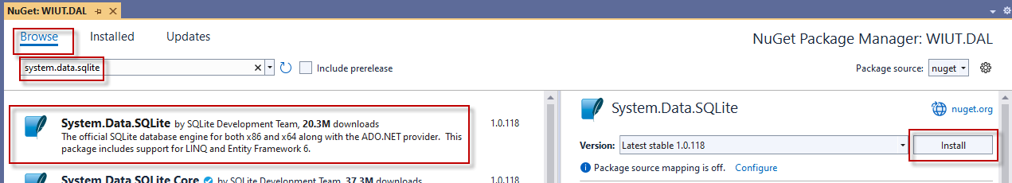

- Add new class to WIUT.DAL project, call it CourseManager

- Make the class public and add imports statement:
using System.Data;
using System.Data.SQLite;

- Create the following functions:
  - public void Create(Course c)
  - public void Update(Course c)
  - public void Delete(int id)
  - public Course GetById(int id)
  - public List<Course> GetAll()

- Add code to the functions (use the code below as example) using the sql statements created in the previous exercise.

public void Create(Course c)
{
using var connection = new SQLiteConnection();
try
{
var sql = $"INSERT INTO Course (Name) VALUES ('{c.Name}')";
using var command = new SQLiteCommand(sql, connection);
connection.Open();
command.ExecuteNonQuery();
}
catch (Exception ex)
{
MessageBox.Show(ex.Message);
}
finally
{
if (connection.State != ConnectionState.Closed)
connection.Close();
}
}

public List<Course> GetAll()
{
using var connection = new SQLiteConnection();
var result = new List<Course>();
try
{
var sql = "SELECT Id, Name FROM Course";
using var command = new SQLiteCommand(sql, connection);
connection.Open();
using var reader = command.ExecuteReader();
while (reader.Read())
{
var c = new Course
{
Id = Convert.ToInt32(reader.GetValue(0)),
Name = Convert.ToString(reader.GetValue(1))
};
result.Add(c);
}
}
catch (Exception ex)
{
MessageBox.Show(ex.Message);
}
finally
{
if (connection.State != ConnectionState.Closed)
connection.Close();
}

return result;
}

Home work
Complete all methods of both CourseManager and ApplicantManager classes

